TM 9 multi-function membrane keyboard

A multi-function touch keyboard is available, which makes it possible for the user to use all the functions available.
This keyboard must always be coupled to a key selector, with at least 2 positions, so that the NIGHT LOCK can be selected electro-mechanically and the keyboard can be enabled with the selector in position 2 (AUTOMATIC).
View of the keyboard:
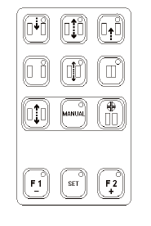APRIMATIC
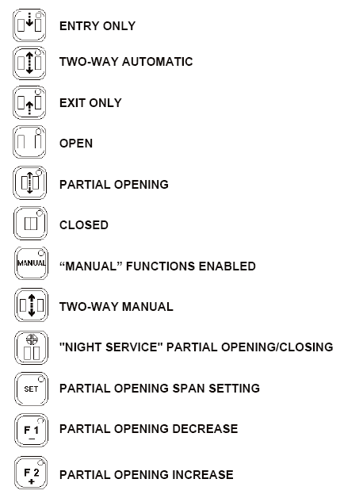
The functions which can be selected by the single keys are as follows:
ENTRY ONLYTWO-WAY AUTOMATICEXIT ONLYOPENPARTIAL OPENINGCLOSED“MANUAL” FUNCTIONS ENABLEDTWO-WAY MANUAL"NIGHT SERVICE" PARTIAL OPENING/CLOSINGPARTIAL OPENING SPAN SETTINGPARTIAL OPENING DECREASEPARTIAL OPENING INCREASE

